- Query all columns for all American cities in the CITY table with populations larger than 100000. The CountryCode for America is USA. The CITY table is described as follows:
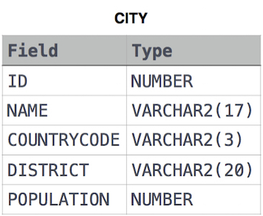
Ans:- select * from city where population>100000 and countrycode="USA";
- Query the NAME field for all American cities in the CITY table with populations larger than 120000. The CountryCode for America is USA.
The CITY table is described above:
Ans:- select name from city where population>120000 and countrycode="USA";
- Query all columns (attributes) for every row in the CITY table.The CITY table is described above:
Ans:- select * from city;
- Query all columns for a city in CITY with the ID 1661.The CITY table is described above:
Ans:- select * from city where id=1661;
- Query all attributes of every Japanese city in the CITY table. The COUNTRYCODE for Japan is JPN.The CITY table is described above:
Ans:- select * from city where countrycode="JPN";
- Query the names of all the Japanese cities in the CITY table. The COUNTRYCODE for Japan is JPN.The CITY table is described above:
Ans:- select name from city where countrycode="JPN";
- Query the average population for all cities in CITY, rounded down to the nearest integer.
Ans:- select round(avg(population)) from city;
- Query the sum of the populations for all Japanese cities in CITY. The COUNTRYCODE for Japan is JPN.
Ans:- select sum(population) from city where countrycode="JPN";
- Query the difference between the maximum and minimum populations in CITY.
Ans:- select max(population)-min(population) from city;
- Query a count of the number of cities in CITY having a Population larger than 100000.
Ans:- select count(*) from city where population>100000;
- Query the total population of all cities in CITY where District is California.
Ans:- select sum(population) from city where district="California";
- Query the average population of all cities in CITY where District is California.
Ans:- select avg(population) from city where district="California";
- Given the CITY and COUNTRY tables, query the sum of the populations of all cities where the CONTINENT is 'Asia'.Note: CITY.CountryCode and COUNTRY.Code are matching key columns.
Input Format: The CITY and COUNTRY tables are described as follows:
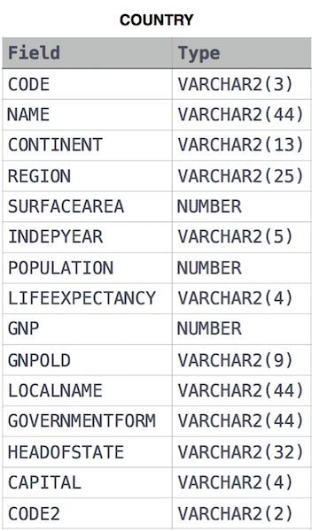
Ans:- SELECT SUM(CITY.POPULATION) FROM CITY
JOIN COUNTRY ON CITY.COUNTRYCODE = COUNTRY.CODE WHERE CONTINENT = 'Asia';
- Given the CITY and COUNTRY tables, query the names of all cities where the CONTINENT is 'Africa'.
Ans:- SELECT CITY.NAME FROM CITY
JOIN COUNTRY ON CITY.COUNTRYCODE = COUNTRY.CODE WHERE CONTINENT = 'Africa';
- Given the CITY and COUNTRY tables, query the names of all the continents (COUNTRY.Continent) and their respective average city populations (CITY.Population) rounded down to the nearest integer.
Ans:- SELECT COUNTRY.CONTINENT,FLOOR(AVG(CITY.POPULATION)) FROM CITY
JOIN COUNTRY ON CITY.COUNTRYCODE = COUNTRY.CODE GROUP BY COUNTRY.CONTINENT;
- Query a list of CITY and STATE from the STATION table.
The STATION table is described as follows:

where LAT_N is the northern latitude and LONG_W is the western longitude.
Ans:- select city,state from station;
- Query a list of CITY names from STATION for cities that have an even ID number. Print the results in any order, but exclude duplicates from the answer.
The STATION table is described above:
Ans:- select distinct(city) from station where mod(id,2)=0;
- Find the difference between the total number of CITY entries in the table and the number of distinct CITY entries in the table.
The STATION table is described above:
Ans:- select count(*)-count(distinct(city)) from station;
- Query the list of CITY names ending with vowels (a, e, i, o, u) from STATION. Your result cannot contain duplicates.
Ans:- select distinct(city) from station where city regexp "[aeiou]$";
- Query the list of CITY names from STATION which have vowels (i.e., a, e, i, o, and u) as both their first and last characters. Your result cannot contain duplicates.
Ans:- select distinct(city) from station where city regexp '^[aeiou].*[aeiou]$';
- Query the list of CITY names from STATION that do not start with vowels. Your result cannot contain duplicates.
Ans:- select distinct(city) from station where city regexp '^[^aeiou]';
- Query the list of CITY names from STATION that do not end with vowels. Your result cannot contain duplicates.
Ans:- select distinct(city) from station where city regexp '[^aeiou]$';
- Query the list of CITY names from STATION that either do not start with vowels or do not end with vowels. Your result cannot contain duplicates.
Ans:- select distinct(city) from station where city regexp '^[^aeiou].*|.*[^aeiou]$';
- Query the list of CITY names from STATION that do not start with vowels and do not end with vowels. Your result cannot contain duplicates.
Ans:- select distinct(city) from station where city regexp '^[^aeiou].*[^aeiou]$';
- Query the Western Longitude (LONG_W)where the smallest Northern Latitude (LAT_N) in STATION is greater than 38.7780. Round your answer to 4 decimal places.
Ans:- select round(long_w,4) from station where lat_n>38.7780 order by lat_n limit 1;
- Query the list of CITY names starting with vowels (i.e., a, e, i, o, or u) from STATION. Your result cannot contain duplicates.
Ans:- select distinct(city) from station where city regexp '^[aeiou].*';
- Query the sum of Northern Latitudes (LAT_N) from STATION having values greater than 38.7880 and less than 137.2345. Truncate your answer to 4 decimal places.
Ans:- select round(sum(lat_n),4) from station where lat_n>38.7780 and lat_n<137.2345;
- Query the following two values from the STATION table: The sum of all values in LAT_N rounded to a scale of 2 decimal places. The sum of all values in LONG_W rounded to a scale of 2 decimal places.
Ans:- select round(sum(lat_n),2),round(sum(long_w),2) from station;
- Query the greatest value of the Northern Latitudes (LAT_N) from STATION that is less than 137.2345. Truncate your answer to 4 decimal places.
Ans:- select round(max(lat_n),4) from station where lat_n<137.2345;
- Query the Western Longitude (LONG_W) for the largest Northern Latitude (LAT_N) in STATION that is less than 137.2345. Round your answer to 4 decimal places.
Ans:- select round(long_w,4) from station where lat_n<137.2345 order by lat_n desc limit 1;
- Query the smallest Northern Latitude (LAT_N) from STATION that is greater than 38.7780. Round your answer to 4 decimal places.
Ans:- select round(min(lat_n),4) from station where lat_n>38.7780;
- Query the median of the Northern Latitudes (LAT_N) from STATION and round your answer to 4 decimal places.
Ans:- SELECT ROUND(AVG(lat_n), 4) AS median
FROM (SELECT lat_n, COUNT(*) OVER() AS cnt, ROW_NUMBER() OVER(ORDER BY lat_n) AS r
FROM station) t
WHERE r IN (FLOOR((cnt + 1) / 2), CEIL((cnt + 1) / 2));
- Query the two cities in STATION with the shortest and longest CITY names, as well as their respective lengths (i.e.: number of characters in the name). If there is more than one smallest or largest city, choose the one that comes first when ordered alphabetically.
Ans:- (SELECT city, LENGTH(city) AS len FROM STATION ORDER BY len, city LIMIT 1) UNION
(SELECT city, LENGTH(city) AS len FROM STATION ORDER BY len DESC, city LIMIT 1);
- Consider P₁(a,b) and P₂(c,d) to be two points on a 2D plane.
a happens to equal the minimum value in Northern Latitude (LAT_N in STATION).
b happens to equal the minimum value in Western Longitude (LONG_W in STATION).
c happens to equal the maximum value in Northern Latitude (LAT_N in STATION).
d happens to equal the maximum value in Western Longitude (LONG_W in STATION).
Query the Manhattan Distance between points P₁ and P₂ and round it to a scale of 4 decimal places.
Ans:- select round(abs(min(lat_n)-max(lat_n))+abs(min(long_w)-max(long_w)),4) from station;
- Consider P₁(a,c) and P₂(b,d) to be two points on a 2D plane where (a,b) are the respective minimum and maximum values of Northern Latitude (LAT_N) and (c,d) are the respective minimum and maximum values of Western Longitude (LONG_W) in STATION.Query the Euclidean Distance between points P₁ and P₂ and format your answer to display 4 decimal digits.
Ans:- select round(sqrt(power(min(lat_n)-max(lat_n),2)+power(min(long_w)-max(long_w),2)),4) from station;
- Write a query that prints a list of employee names (i.e.: the name attribute) from the Employee table in alphabetical order.
Input Format: The Employee table containing employee data for a company is described as follows:
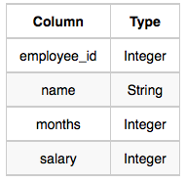
where employee_id is an employee's ID number, name is their name, months is the total number of months they've been working for the company, and salary is their monthly salary.
Ans:- select name from employee order by name;
- Write a query that prints a list of employee names (i.e.: the name attribute) for employees in Employee having a salary greater than 2000 per month who have been employees for less than 10 months. Sort your result by ascending employee_id.
Ans:- select name from employee where salary>2000 and months<10 order by employee_id;
- We define an employee's total earnings to be their monthly salary*months worked, and the maximum total earnings to be the maximum total earnings for any employee in the Employee table. Write a query to find the maximum total earnings for all employees as well as the total number of employees who have maximum total earnings. Then print these values as 2 space-separated integers.
Sample Input: 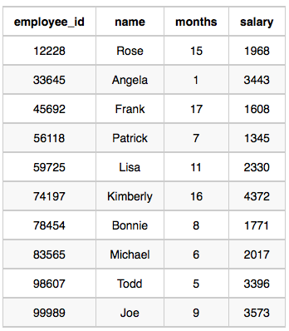
Sample Output: 69952 1
Ans:- SELECT MAX(total_earnings), COUNT(*)
FROM (SELECT employee_id, salary * months AS total_earnings FROM Employee) t
WHERE total_earnings = (SELECT MAX(salary * months) FROM Employee);
- Query the Name of any student in STUDENTS who scored higher than Marks 75. Order your output by the last three characters of each name. If two or more students both have names ending in the same last three characters (i.e.: Bobby, Robby, etc.), secondary sort them by ascending ID.
Input Format:
The STUDENTS table is described as follows: 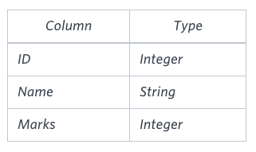 The Name column only contains uppercase (A-Z) and lowercase (a-z) letters.
Ans:- select name from students where marks>75 order by right(name,3),ID;
- Write a query identifying the type of each record in the TRIANGLES table using its three side lengths. Output one of the following statements for each record in the table: Equilateral: It's a triangle with 3 sides of equal length. Isosceles: It's a triangle with 2 sides of equal length. Scalene: It's a triangle with 3 sides of differing lengths. Not A Triangle: The given values of A, B, and C don't form a triangle.
Input Format: The TRIANGLES table is described as follows:
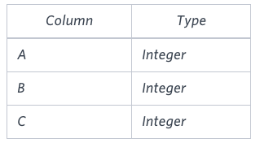
Each row in the table denotes the lengths of each of a triangle's three sides.
Sample Input: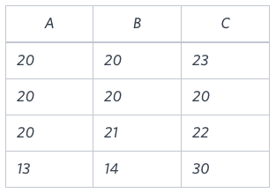
Sample Output:
Isosceles
Equilateral
Scalene
Not A Triangle
Ans:- SELECT CASE
WHEN A + B <= C OR A + C <= B OR B + C <= A THEN 'Not A Triangle'
WHEN A = B AND B = C THEN 'Equilateral'
WHEN A = B OR B = C OR A = C THEN 'Isosceles'
ELSE 'Scalene'
END FROM TRIANGLES;
- You are given a table, BST, containing two columns: N and P, where N represents the value of a node in Binary Tree, and P is the parent of N.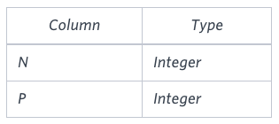
Write a query to find the node type of Binary Tree ordered by the value of the node. Output one of the following for each node:
- Root: If node is root node.
- Leaf: If node is leaf node.
- Inner: If node is neither root nor leaf node.
Sample Input: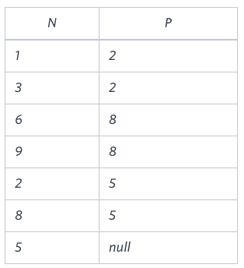
Sample Output: 1 Leaf
2 Inner
3 Leaf
5 Root
6 Leaf
8 Inner
9 Leaf
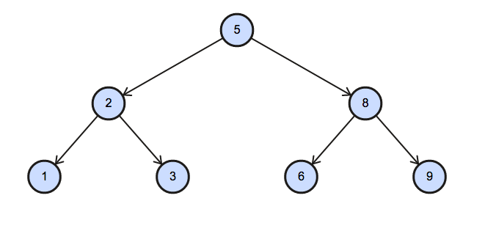
Ans:- SELECT N, CASE
WHEN P IS NULL THEN 'Root'
WHEN N IN (SELECT DISTINCT P FROM BST) THEN 'Inner'
ELSE 'Leaf'
END FROM BST ORDER BY N;
- Samantha was tasked with calculating the average monthly salaries for all employees in the EMPLOYEES table, but did not realize her keyboard's 0 key was broken until after completing the calculation. She wants your help finding the difference between her miscalculation (using salaries with any zeros removed), and the actual average salary.
Write a query calculating the amount of error (i.e.: average monthly salaries), and round it up to the next integer.
Input Format: The EMPLOYEES table is described as follows: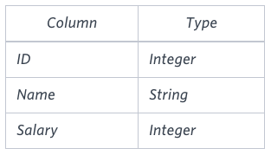
Note: Salary is per month..
Sample Input:
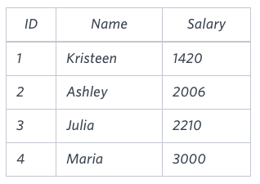
Sample Output: 2061
Ans:- SELECT CEIL(AVG(salary) - AVG(REPLACE(salary, '0', ''))) FROM EMPLOYEES;
- P(R) represents a pattern drawn by Julia in R rows. The following pattern represents P(5):
* * * * *
* * * *
* * *
* *
*
Write a query to print the pattern P(20).
Ans:- DELIMITER //
SET @@max_sp_recursion_depth = 20;
CREATE PROCEDURE P(IN N INT)
BEGIN
IF N > 0 THEN
SELECT REPEAT('* ', N);
CALL P(N - 1);
END IF;
END //
DELIMITER ;
call P(20);
- P(R) represents a pattern drawn by Julia in R rows. The following pattern represents P(5):
*
* *
* * *
* * * *
* * * * *
Write a query to print the pattern P(20).
Ans:- DELIMITER //
SET @@max_sp_recursion_depth = 20;
CREATE PROCEDURE P(IN N INT, IN i INT)
BEGIN
IF i <= N THEN
SELECT REPEAT('* ', i);
CALL P(N, i + 1);
END IF;
END //
DELIMITER ;
call P(20,1);
- Generate the following two result sets:
- Query an alphabetically ordered list of all names in OCCUPATIONS, immediately followed by the first letter of each profession as a parenthetical (i.e.: enclosed in parentheses). For example: AnActorName(A), ADoctorName(D), AProfessorName(P), and ASingerName(S).
- Query the number of ocurrences of each occupation in OCCUPATIONS. Sort the occurrences in ascending order, and output them in the following format:
- There are a total of [occupation_count] [occupation]s.
where [occupation_count] is the number of occurrences of an occupation in OCCUPATIONS and [occupation] is the lowercase occupation name. If more than one Occupation has the same [occupation_count], they should be ordered alphabetically.
Note: There will be at least two entries in the table for each type of occupation.
Input Format: The OCCUPATIONS table is described as follows: 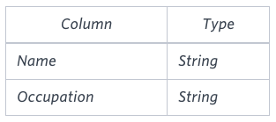
Occupation will only contain one of the following values: Doctor, Professor, Singer or Actor.
Sample Input: An OCCUPATIONS table that contains the following records:
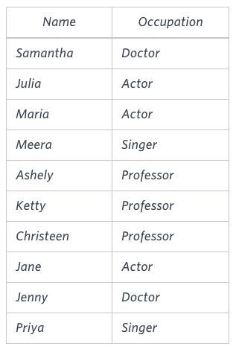
Sample Output: Ashely(P)
Christeen(P)
Jane(A)
Jenny(D)
Julia(A)
Ketty(P)
Maria(A)
Meera(S)
Priya(S)
Samantha(D)
There are a total of 2 doctors.
There are a total of 2 singers.
There are a total of 3 actors.
There are a total of 3 professors.
Ans:- SELECT CONCAT(Name, '(', SUBSTRING(Occupation, 1, 1), ')') FROM OCCUPATIONS ORDER BY Name;
SELECT CONCAT('There are a total of ', COUNT(*), ' ', LOWER(Occupation), 's.') FROM OCCUPATIONS GROUP BY Occupation ORDER BY COUNT(*), Occupation;
- You are given three tables: Students, Friends and Packages. Students contains two columns: ID and Name. Friends contains two columns: ID and Friend_ID (ID of the ONLY best friend). Packages contains two columns: ID and Salary (offered salary in $ thousands per month).
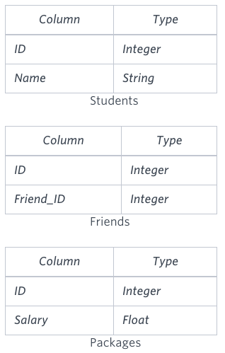
Write a query to output the names of those students whose best friends got offered a higher salary than them. Names must be ordered by the salary amount offered to the best friends. It is guaranteed that no two students got same salary offer.
Sample Input
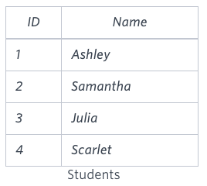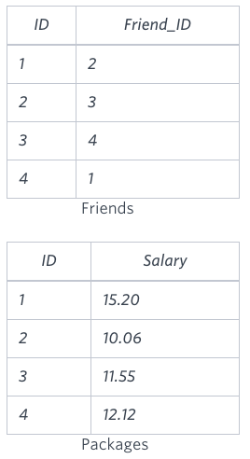
Sample Output
Samantha
Julia
Scarlet
Ans:- SELECT S.Name FROM Students S
JOIN Friends F ON S.ID = F.ID
JOIN Packages P1 ON S.ID = P1.ID
JOIN Packages P2 ON F.Friend_ID = P2.ID
WHERE P2.Salary > P1.Salary ORDER BY P2.Salary;
- Harry Potter and his friends are at Ollivander's with Ron, finally replacing Charlie's old broken wand.
Hermione decides the best way to choose is by determining the minimum number of gold galleons needed to buy each non-evil wand of high power and age. Write a query to print the id, age, coins_needed, and power of the wands that Ron's interested in, sorted in order of descending power. If more than one wand has same power, sort the result in order of descending age.
Input Format
The following tables contain data on the wands in Ollivander's inventory:
- Wands: The id is the id of the wand, code is the code of the wand, coins_needed is the total number of gold galleons needed to buy the wand, and power denotes the quality of the wand (the higher the power, the better the wand is). 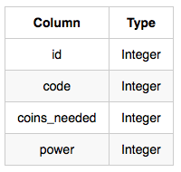
- Wands_Property: The code is the code of the wand, age is the age of the wand, and is_evil denotes whether the wand is good for the dark arts. If the value of is_evil is 0, it means that the wand is not evil. The mapping between code and age is one-one, meaning that if there are two pairs, (code₁,age₁) and (code₂,age₂), then code₁ != code₂ and age₁ != age₂.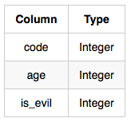
Sample Input:
Wands Table: 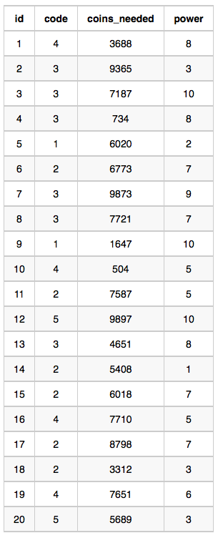 Wands_Property Table: 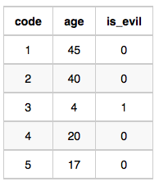
Sample Output
9 45 1647 10
12 17 9897 10
1 20 3688 8
15 40 6018 7
19 20 7651 6
11 40 7587 5
10 20 504 5
18 40 3312 3
20 17 5689 3
5 45 6020 2
14 40 5408 1
Explanation: The data for wands of age 45 (code 1): 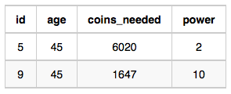
Ans:- SELECT w.id, wp.age, w.coins_needed, w.power
FROM Wands w JOIN Wands_Property wp ON w.code = wp.code
WHERE wp.is_evil = 0 AND w.coins_needed = (
SELECT MIN(coins_needed)
FROM Wands w1
JOIN Wands_Property wp1 ON w1.code = wp1.code
WHERE w1.power = w.power AND wp1.age = wp.age)
ORDER BY w.power DESC, wp.age DESC;
- You did such a great job helping Julia with her last coding contest challenge that she wants you to work on this one, too!
The total score of a hacker is the sum of their maximum scores for all of the challenges. Write a query to print the hacker_id, name, and total score of the hackers ordered by the descending score. If more than one hacker achieved the same total score, then sort the result by ascending hacker_id. Exclude all hackers with a total score of 0 from your result.
Input Format
The following tables contain contest data:
- Hackers: The hacker_id is the id of the hacker, and name is the name of the hacker. 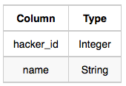
- Submissions: The submission_id is the id of the submission, hacker_id is the id of the hacker who made the submission, challenge_id is the id of the challenge for which the submission belongs to, and score is the score of the submission. 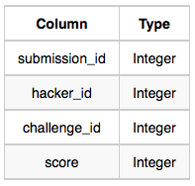
Sample Input
Hackers Table: 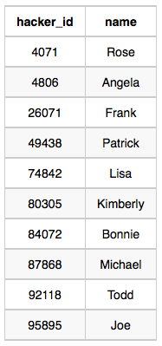
Submissions Table: 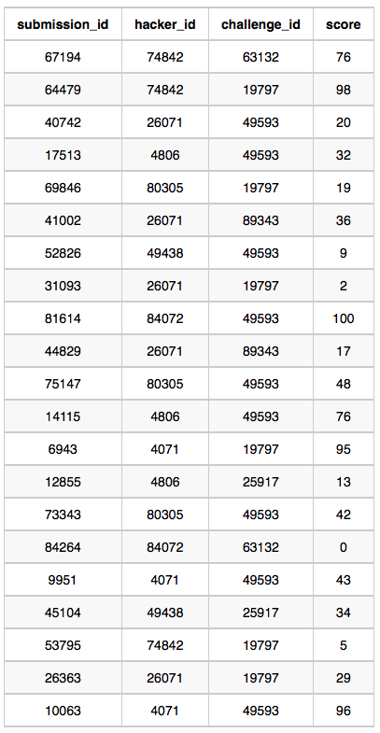
Sample Output
4071 Rose 191
74842 Lisa 174
84072 Bonnie 100
4806 Angela 89
26071 Frank 85
80305 Kimberly 67
49438 Patrick 43
Ans:- SELECT h.hacker_id, h.name, SUM(max_score) as total_score
FROM Hackers h JOIN (SELECT hacker_id, MAX(score) as max_score
FROM Submissions GROUP BY hacker_id, challenge_id) s
ON h.hacker_id = s.hacker_id
GROUP BY h.hacker_id, h.name HAVING total_score > 0
ORDER BY total_score DESC, h.hacker_id;
- Amber's conglomerate corporation just acquired some new companies. Each of the companies follows this hierarchy: 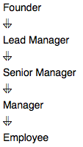
Given the table schemas below, write a query to print the company_code, founder name, total number of lead managers, total number of senior managers, total number of managers, and total number of employees. Order your output by ascending company_code.
Note:
- The tables may contain duplicate records.
- The company_code is string, so the sorting should not be numeric. For example, if the company_codes are C_1, C_2, and C_10, then the ascending company_codes will be C_1, C_10, and C_2.
Input Format: The following tables contain company data:
- Company: The company_code is the code of the company and founder is the founder of the company. 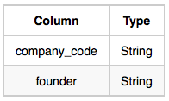
- Lead_Manager: The lead_manager_code is the code of the lead manager, and the company_code is the code of the working company. 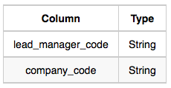
- Senior_Manager: The senior_manager_code is the code of the senior manager, the lead_manager_code is the code of its lead manager, and the company_code is the code of the working company. 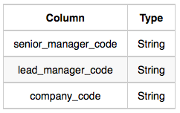
- Manager: The manager_code is the code of the manager, the senior_manager_code is the code of its senior manager, the lead_manager_code is the code of its lead manager, and the company_code is the code of the working company. 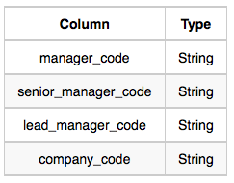
- Employee: The employee_code is the code of the employee, the manager_code is the code of its manager, the senior_manager_code is the code of its senior manager, the lead_manager_code is the code of its lead manager, and the company_code is the code of the working company. 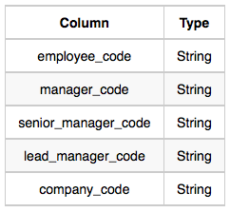
Ans:- SELECT C.company_code, C.founder,
COUNT(DISTINCT LM.lead_manager_code) AS num_lead_managers,
COUNT(DISTINCT SM.senior_manager_code) AS num_senior_managers,
COUNT(DISTINCT M.manager_code) AS num_managers,
COUNT(DISTINCT E.employee_code) AS num_employees
FROM Company C
LEFT JOIN Lead_Manager LM ON C.company_code = LM.company_code
LEFT JOIN Senior_Manager SM ON C.company_code = SM.company_code
LEFT JOIN Manager M ON C.company_code = M.company_code
LEFT JOIN Employee E ON C.company_code = E.company_code
GROUP BY C.company_code, C.founder
ORDER BY C.company_code;
- Julia just finished conducting a coding contest, and she needs your help assembling the leaderboard! Write a query to print the respective hacker_id and name of hackers who achieved full scores for more than one challenge. Order your output in descending order by the total number of challenges in which the hacker earned a full score. If more than one hacker received full scores in same number of challenges, then sort them by ascending hacker_id.
Input Format: The following tables contain contest data:
- Hackers: The hacker_id is the id of the hacker, and name is the name of the hacker. 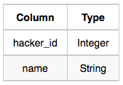
- Difficulty: The difficult_level is the level of difficulty of the challenge, and score is the score of the challenge for the difficulty level. 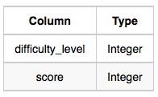
- Challenges: The challenge_id is the id of the challenge, the hacker_id is the id of the hacker who created the challenge, and difficulty_level is the level of difficulty of the challenge. 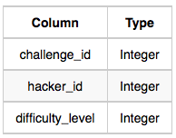
- Submissions: The submission_id is the id of the submission, hacker_id is the id of the hacker who made the submission, challenge_id is the id of the challenge that the submission belongs to, and score is the score of the submission. 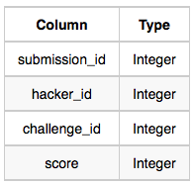
Ans:- SELECT h.hacker_id, h.name FROM Hackers h
JOIN (
SELECT s.hacker_id
FROM Submissions s
JOIN Challenges c ON s.challenge_id = c.challenge_id
JOIN Difficulty d ON c.difficulty_level = d.difficulty_level
WHERE s.score = d.score
GROUP BY s.hacker_id
HAVING COUNT(s.challenge_id) > 1
) AS full_score_hackers ON h.hacker_id = full_score_hackers.hacker_id
ORDER BY (
SELECT COUNT(*) FROM Submissions s
JOIN Challenges c ON s.challenge_id = c.challenge_id
JOIN Difficulty d ON c.difficulty_level = d.difficulty_level
WHERE s.hacker_id = h.hacker_id AND s.score = d.score
) DESC, h.hacker_id;
- You are given two tables: Students and Grades. Students contains three columns ID, Name and Marks.
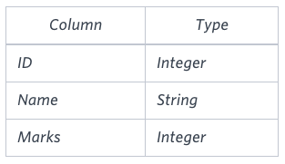
Grades contains the following data:
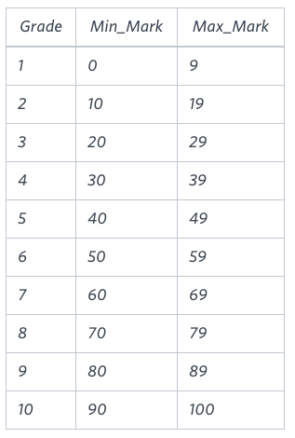
Ketty gives Eve a task to generate a report containing three columns: Name, Grade and Mark. Ketty doesn't want the NAMES of those students who received a grade lower than 8. The report must be in descending order by grade -- i.e. higher grades are entered first. If there is more than one student with the same grade (8-10) assigned to them, order those particular students by their name alphabetically. Finally, if the grade is lower than 8, use "NULL" as their name and list them by their grades in descending order. If there is more than one student with the same grade (1-7) assigned to them, order those particular students by their marks in ascending order.
Write a query to help Eve.
Ans:- SELECT
CASE
WHEN g.Grade >= 8 THEN s.Name
WHEN g.Grade<8 THEN "NULL"
END AS Name, g.Grade, s.Marks
FROM Students s JOIN Grades g ON s.Marks BETWEEN g.Min_Mark AND g.Max_Mark
ORDER BY Grade DESC, Name, Marks;
- Julia asked her students to create some coding challenges. Write a query to print the hacker_id, name, and the total number of challenges created by each student. Sort your results by the total number of challenges in descending order. If more than one student created the same number of challenges, then sort the result by hacker_id. If more than one student created the same number of challenges and the count is less than the maximum number of challenges created, then exclude those students from the result.
Input Format: The following tables contain challenge data:
Hackers: The hacker_id is the id of the hacker, and name is the name of the hacker. 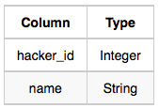
Challenges: The challenge_id is the id of the challenge, and hacker_id is the id of the student who created the challenge. 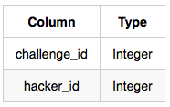
Ans:- SELECT h.hacker_id, h.name, COUNT(c.challenge_id) AS c_count
FROM Hackers h JOIN Challenges c ON c.hacker_id = h.hacker_id
GROUP BY h.hacker_id, h.name
HAVING c_count = (
SELECT COUNT(c2.challenge_id) AS c_max
FROM challenges as c2
GROUP BY c2.hacker_id ORDER BY c_max DESC LIMIT 1)
OR c_count IN (
SELECT c_compare as c_unique
FROM (SELECT h2.hacker_id, h2.name, COUNT(challenge_id) AS c_compare
FROM Hackers h2 JOIN Challenges c ON c.hacker_id = h2.hacker_id
GROUP BY h2.hacker_id, h2.name) counts
GROUP BY c_compare HAVING COUNT(*) = 1)
ORDER BY c_count DESC, h.hacker_id;
- Pivot the Occupation column in OCCUPATIONS so that each Name is sorted alphabetically and displayed underneath its corresponding Occupation. The output column headers should be Doctor, Professor, Singer, and Actor, respectively.
Note: Print NULL when there are no more names corresponding to an occupation.
Input Format: The OCCUPATIONS table is described as follows:
Occupation will only contain one of the following values: Doctor, Professor, Singer or Actor.
Ans:- SET @r1=0, @r2=0, @r3=0, @r4=0;
SELECT MIN(Doctor), MIN(Professor), MIN(Singer), MIN(Actor)
FROM (SELECT
CASE
WHEN Occupation = "Doctor" THEN (@r1:=@r1+1)
WHEN Occupation = "Professor" THEN (@r2:=@r2+1)
WHEN Occupation = "Singer" THEN (@r3:=@r3+1)
WHEN Occupation = "Actor" THEN (@r4:=@r4+1)
END AS RowNumber,
CASE WHEN Occupation = "Doctor" THEN Name END AS Doctor,
CASE WHEN Occupation = "Professor" THEN Name END AS Professor,
CASE WHEN Occupation = "Singer" THEN Name END AS Singer,
CASE WHEN Occupation = "Actor" THEN Name END AS Actor
FROM OCCUPATIONS ORDER BY Name) Temp GROUP BY RowNumber;
- You are given a table, Functions, containing two columns: X and Y.
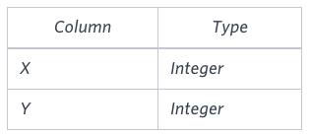
Two pairs (X₁, Y₁) and (X₂, Y₂) are said to be symmetric pairs if X₁ = Y₂ and X₂ = Y₁.
Write a query to output all such symmetric pairs in ascending order by the value of X. List the rows such that X₁ ≤ Y₁.
Ans:- SELECT f1.X, f1.Y FROM Functions AS f1
WHERE f1.X = f1.Y AND
(SELECT COUNT(*) FROM Functions WHERE X = f1.X AND Y = f1.Y) > 1
UNION
SELECT f1.X, f1.Y from Functions AS f1
WHERE EXISTS(SELECT X, Y FROM Functions WHERE f1.X = Y AND f1.Y = X AND f1.X < X)
ORDER BY X;
- You are given a table, Projects, containing three columns: Task_ID, Start_Date and End_Date. It is guaranteed that the difference between the End_Date and the Start_Date is equal to 1 day for each row in the table.
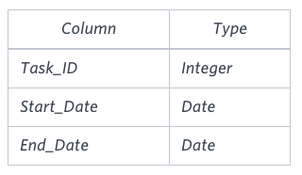
If the End_Date of the tasks are consecutive, then they are part of the same project. Samantha is interested in finding the total number of different projects completed.
Write a query to output the start and end dates of projects listed by the number of days it took to complete the project in ascending order. If there is more than one project that have the same number of completion days, then order by the start date of the project.
Ans:- SELECT Start_Date, MIN(End_Date)
FROM (SELECT Start_Date FROM Projects
WHERE Start_Date NOT IN (SELECT End_Date FROM Projects)) s,
(SELECT End_Date FROM Projects
WHERE End_Date NOT IN (SELECT Start_Date FROM Projects)) e
WHERE Start_Date < End_Date GROUP BY Start_Date
ORDER BY DATEDIFF(MIN(End_Date), Start_Date), Start_Date;

